Required:
    - Screenshot from each group with users and permissions attached to it
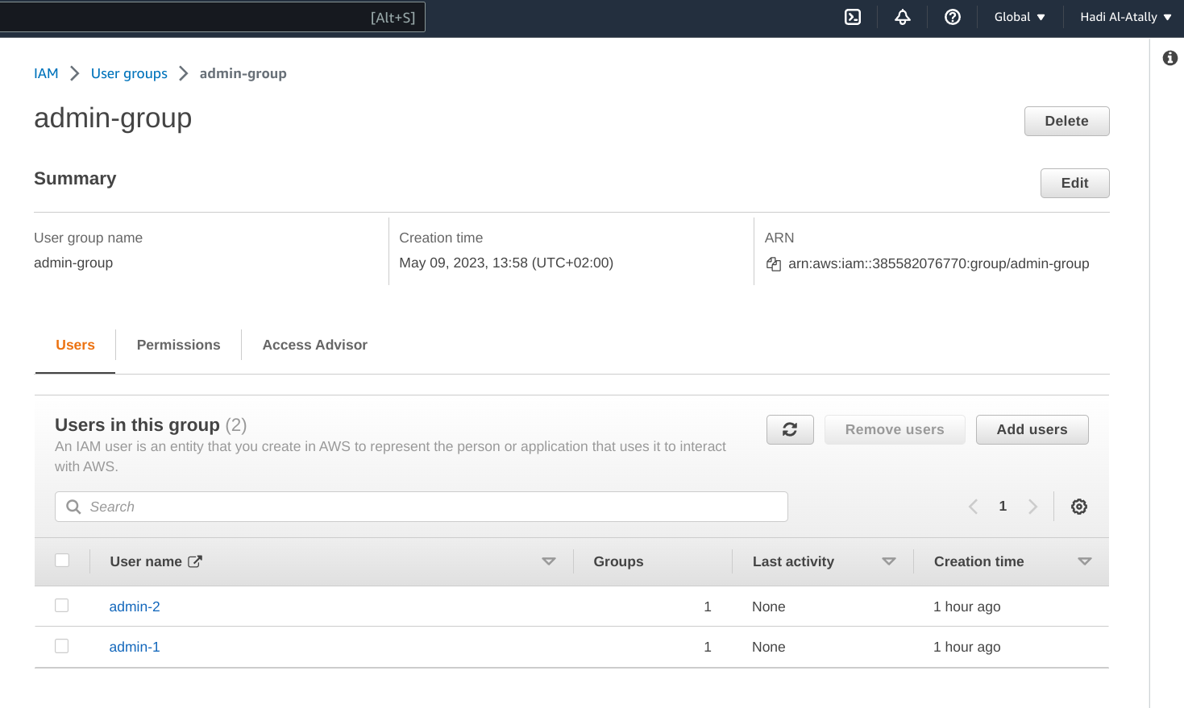
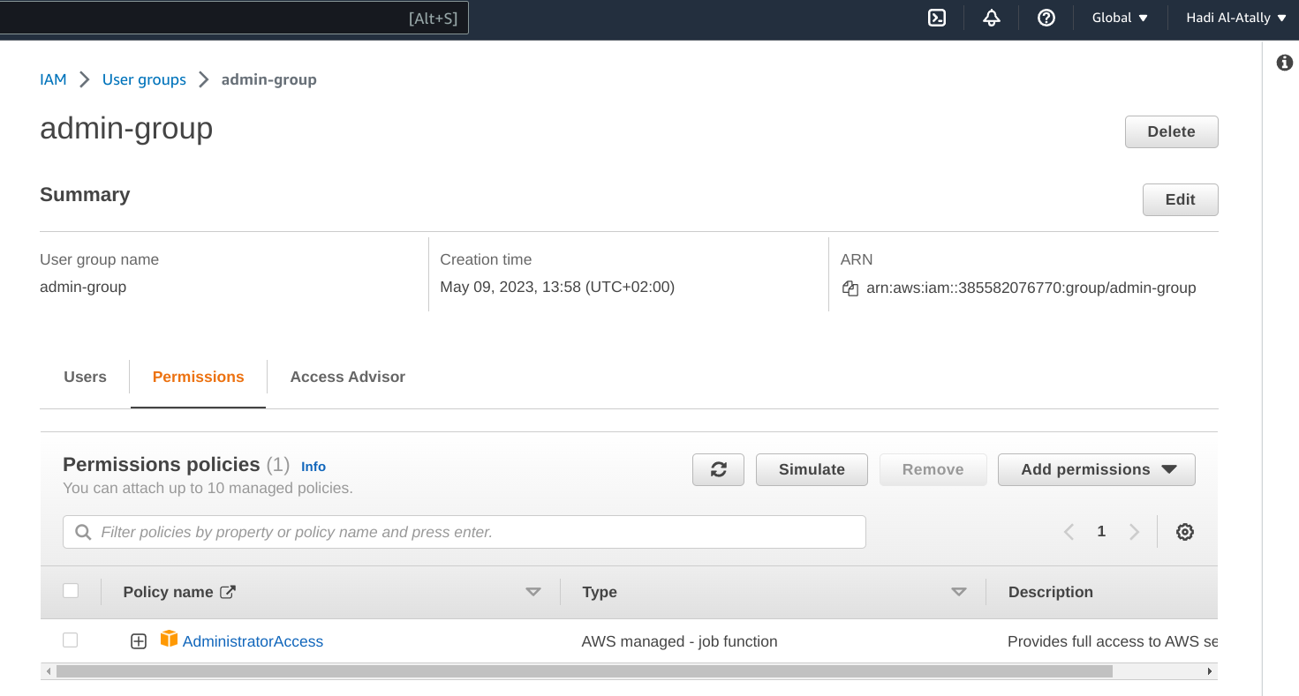

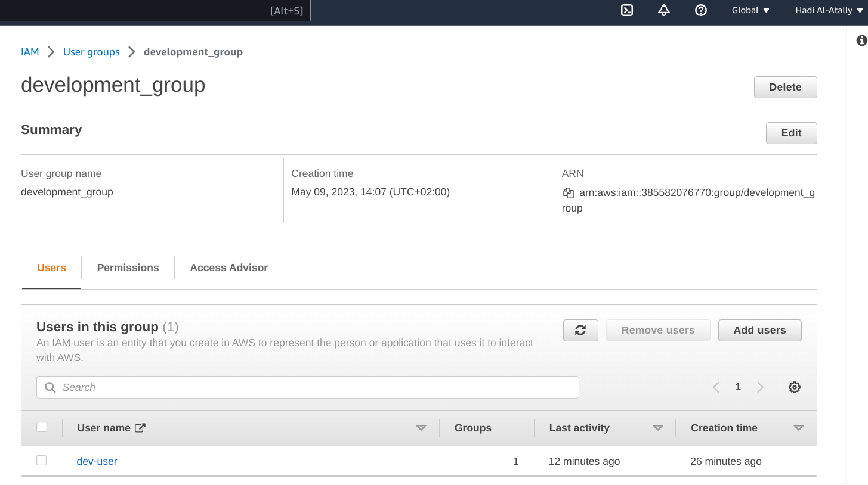
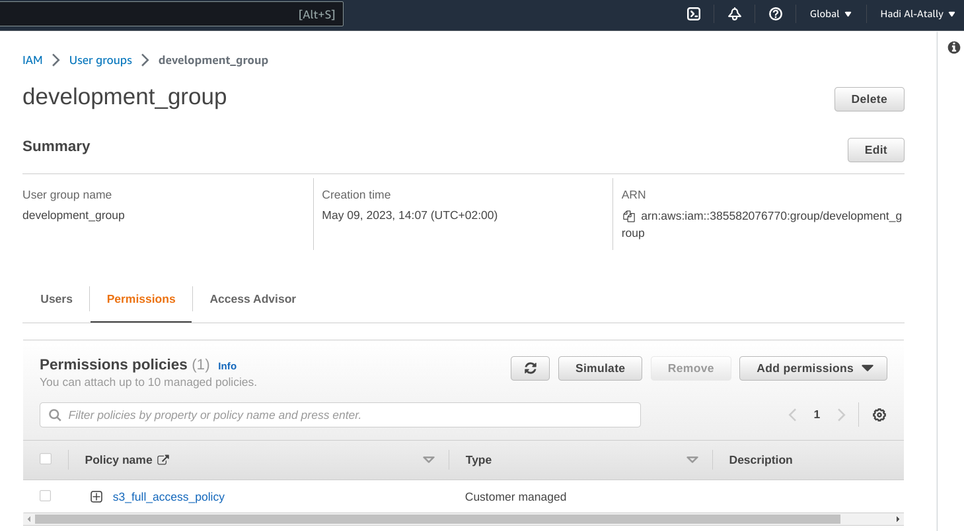

    - Screenshot from using dev-user to access ec2 and s3 from console
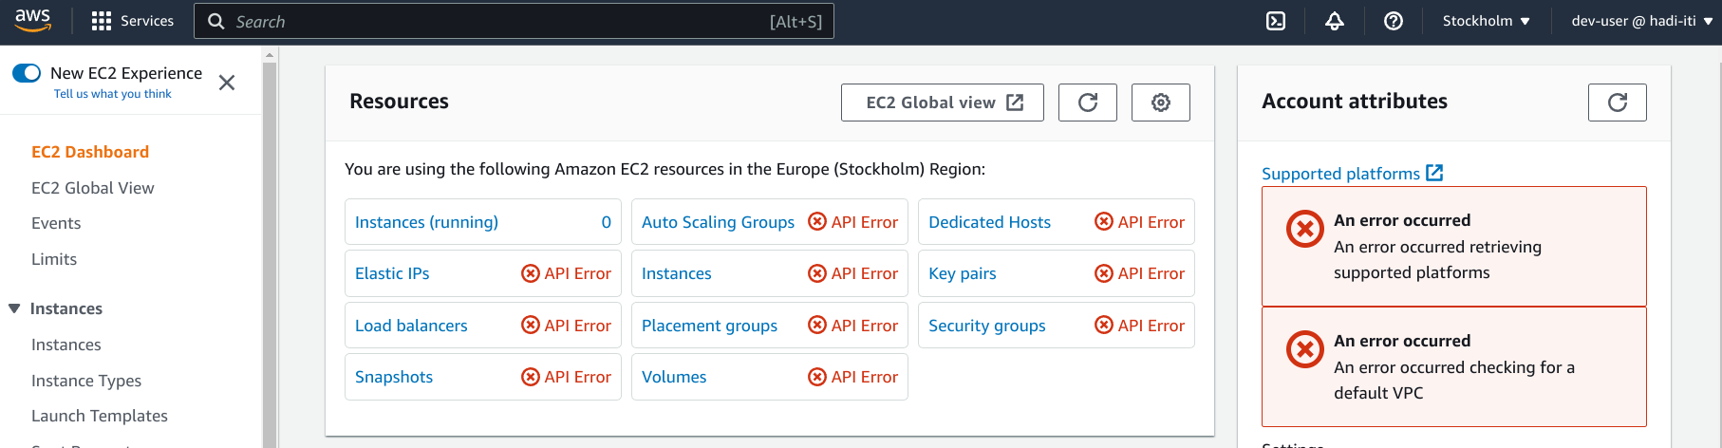
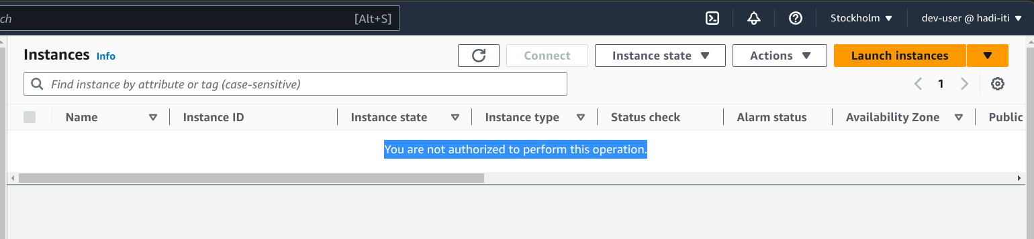
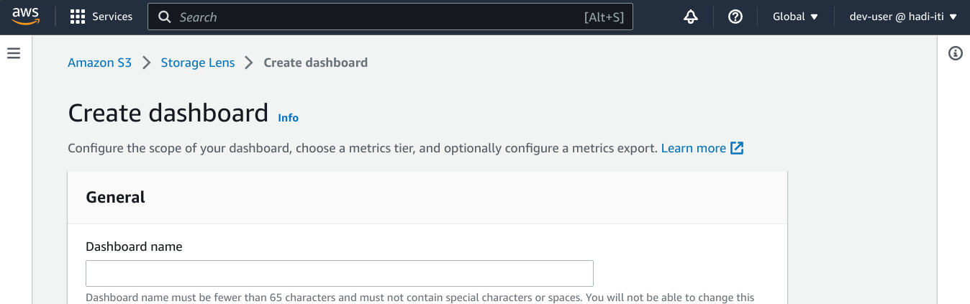

    - Screenshot from listing users and groups using admin2-prog
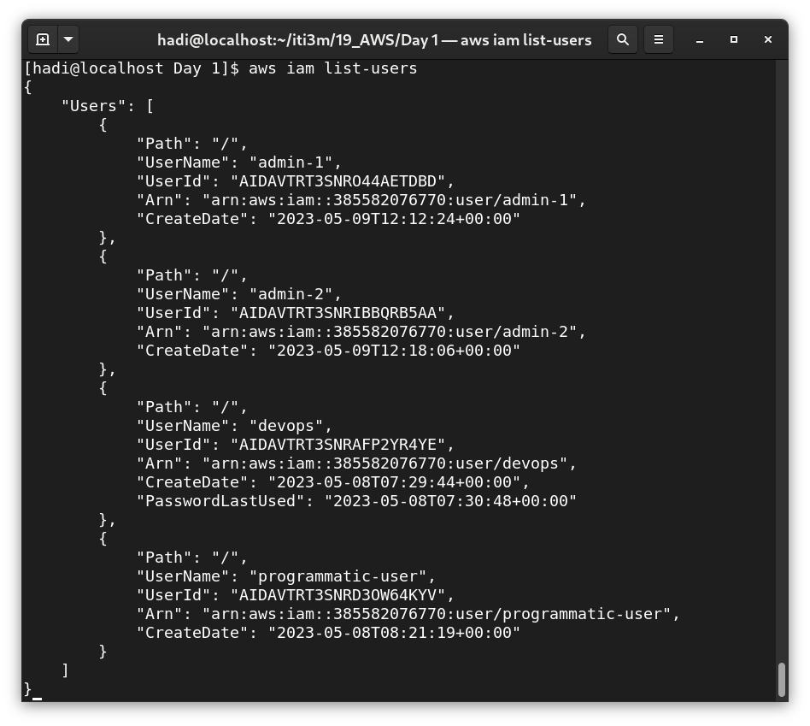

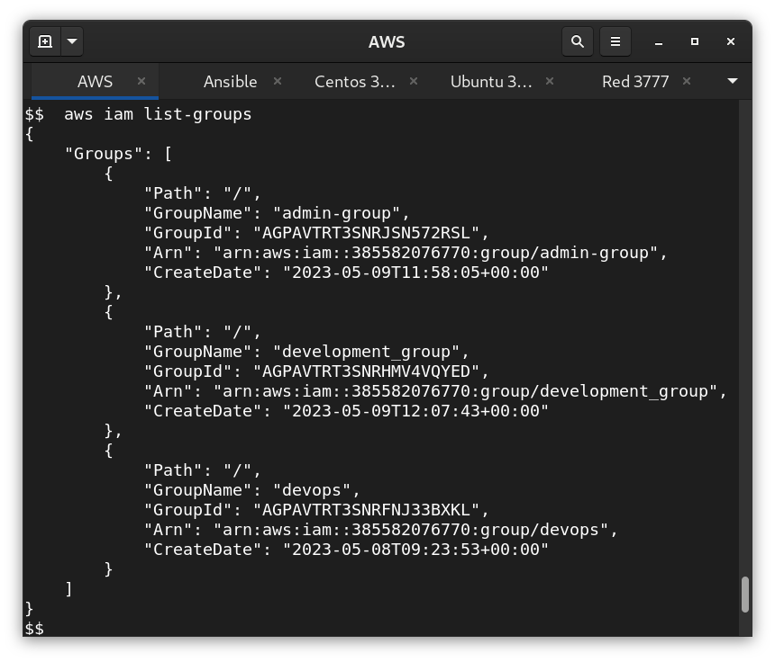

    - Screenshot from listing users and groups using dev-users

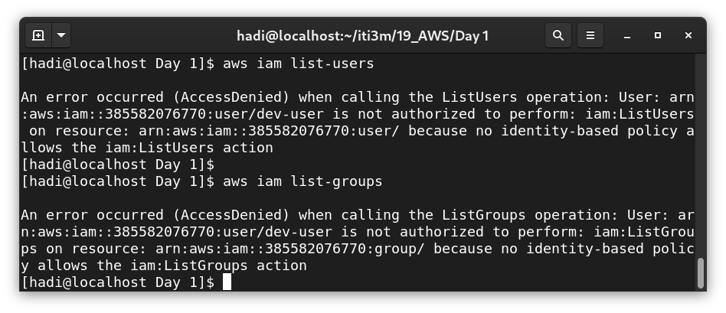

- Create ec2 and install apache2 on it.
Required: screenshot From accessing the machine public ip from the browser C2 General

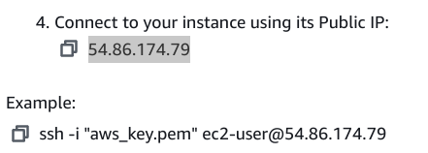

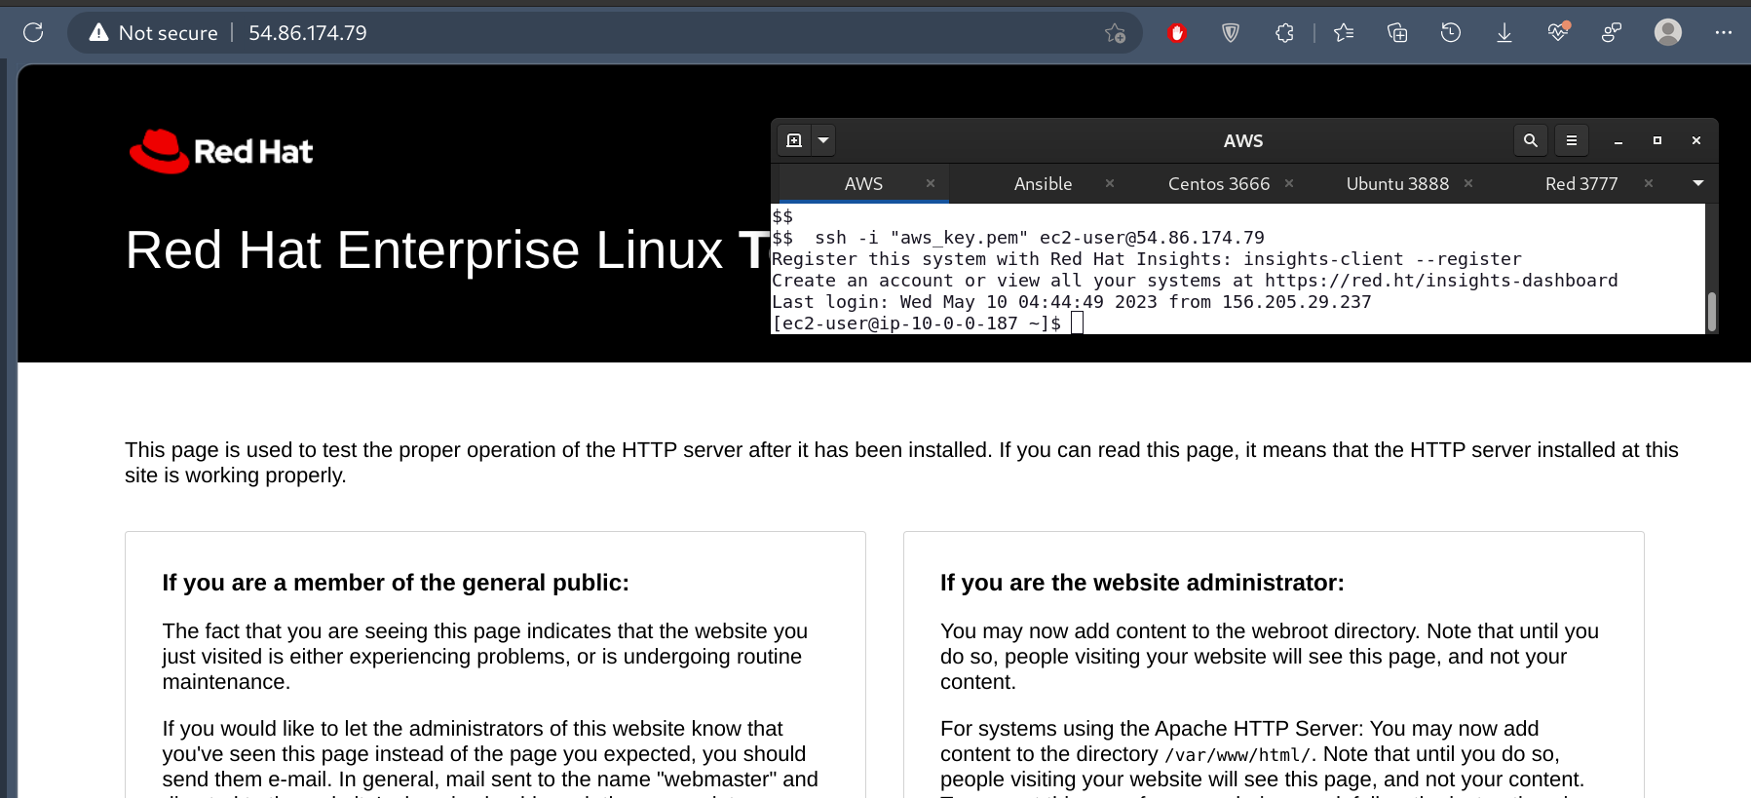
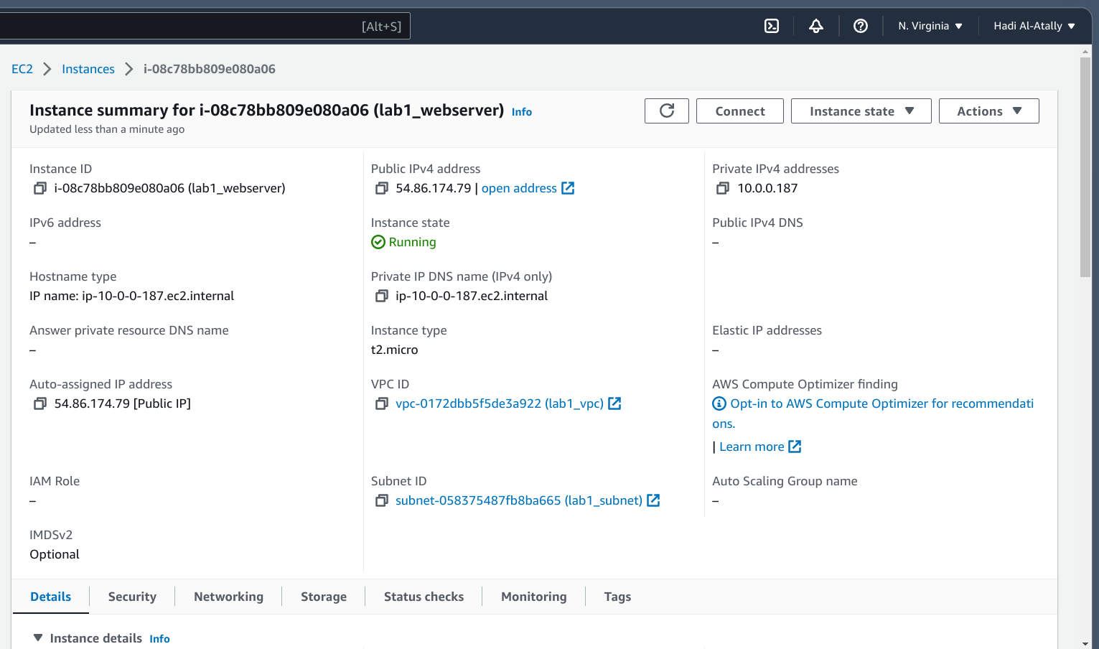

Other Work(not reqired output)

BY Sabreen Salama
AWS LAB1:
- Create aws account and set billing alarm
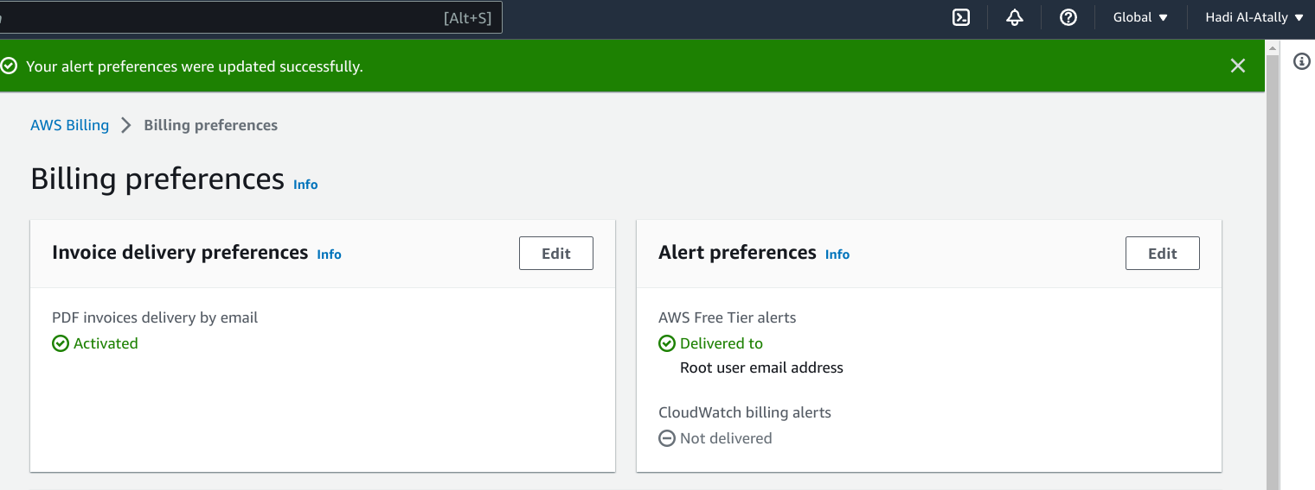
- create 2 groups one admin and one for development
  - in the admin group it has admin permission , and in the development only access to s3
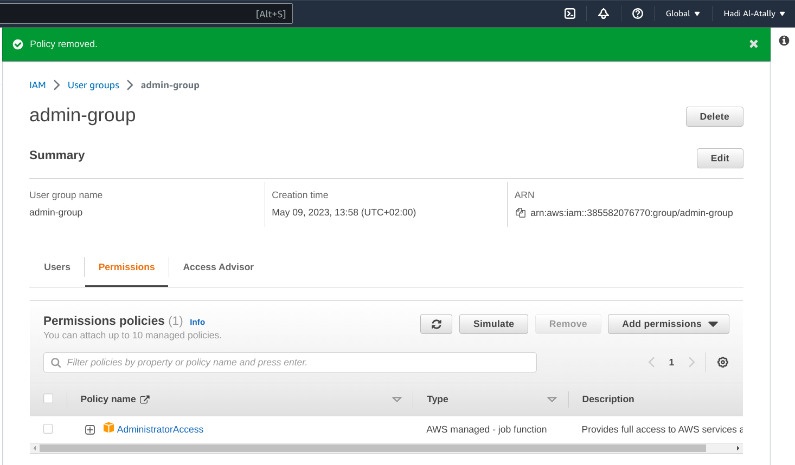
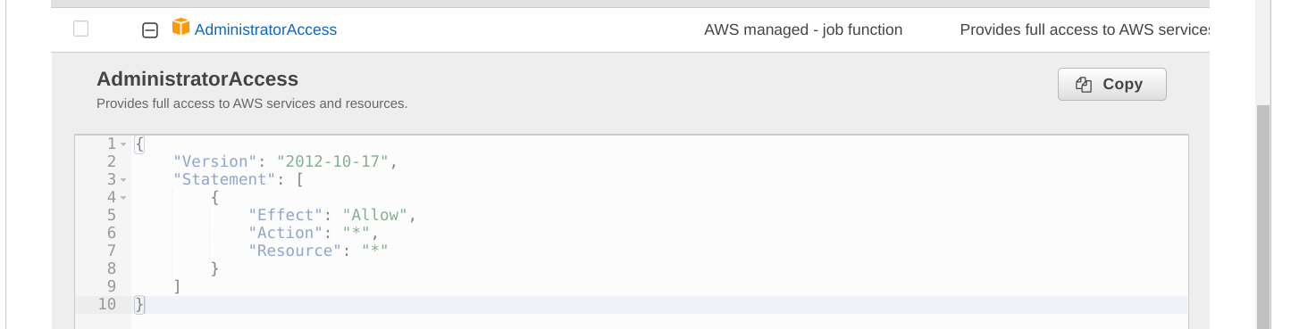
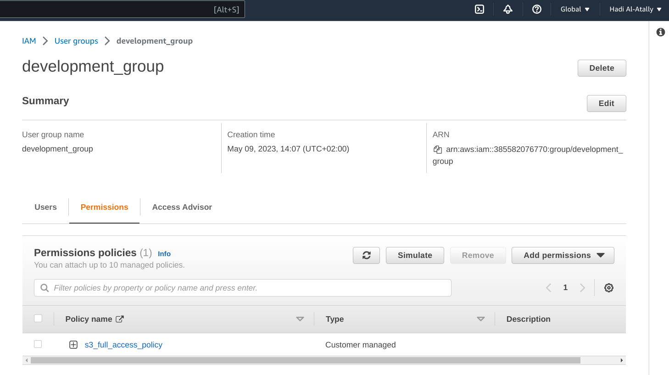
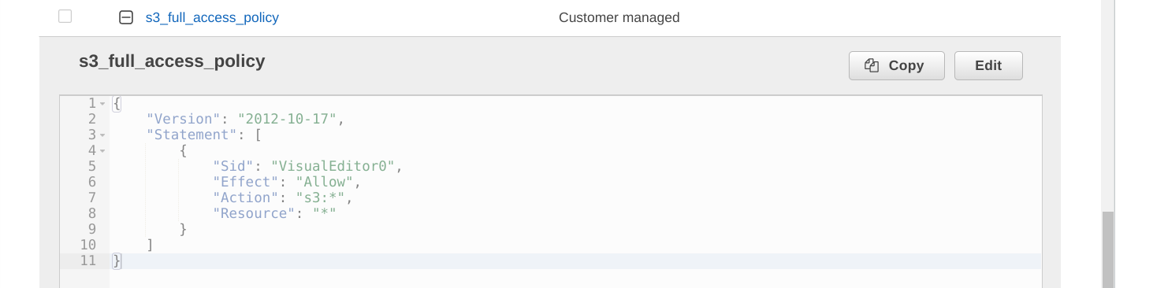
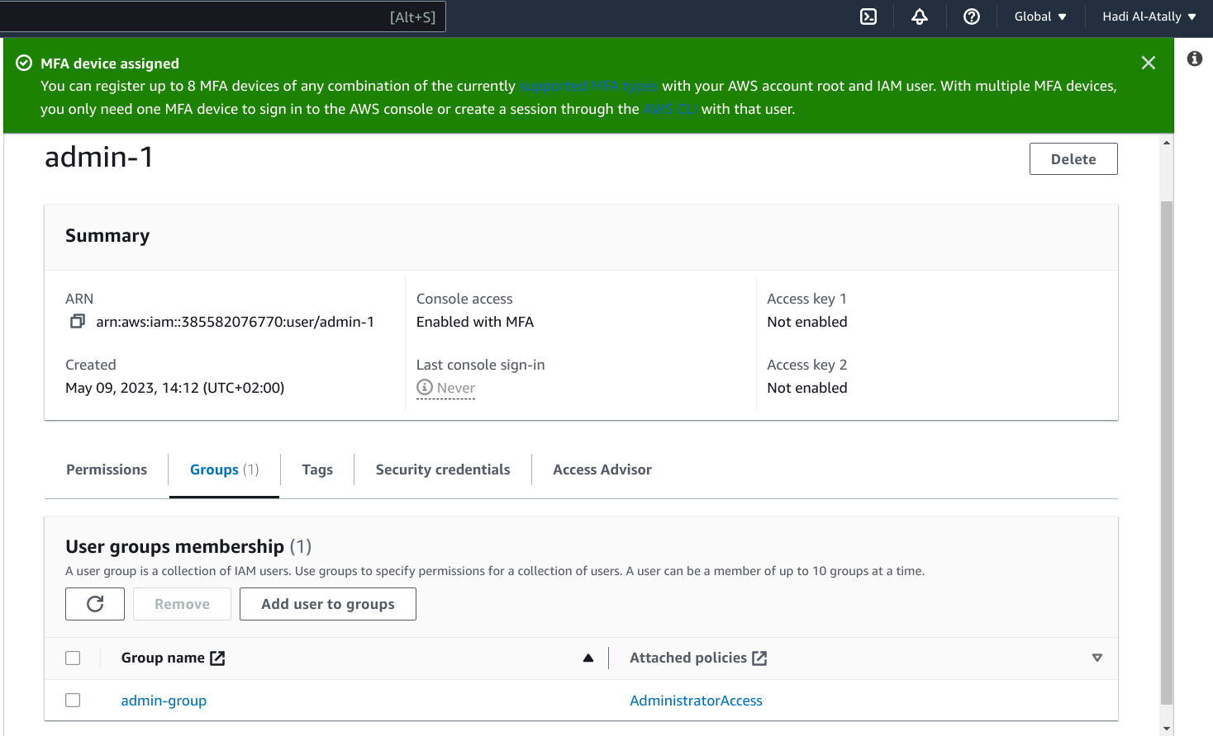
  - create admin-1 user console access and mfa enabled in admin group
  - and admin2-prog with cli access only and list all users and groups using commands not console
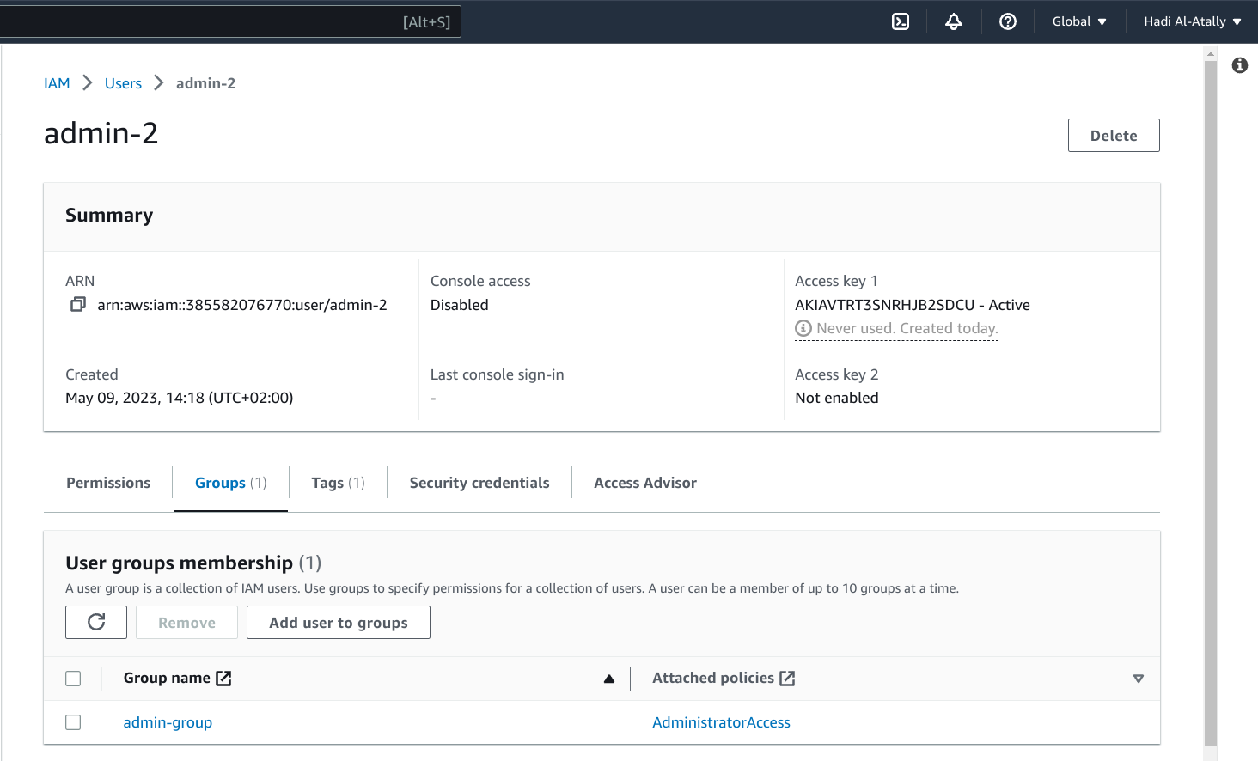

  - in the development group create user with name dev-user with programmatic and console access then try to access aws using it (take a screenshot from accessing ec2 and s3 console)

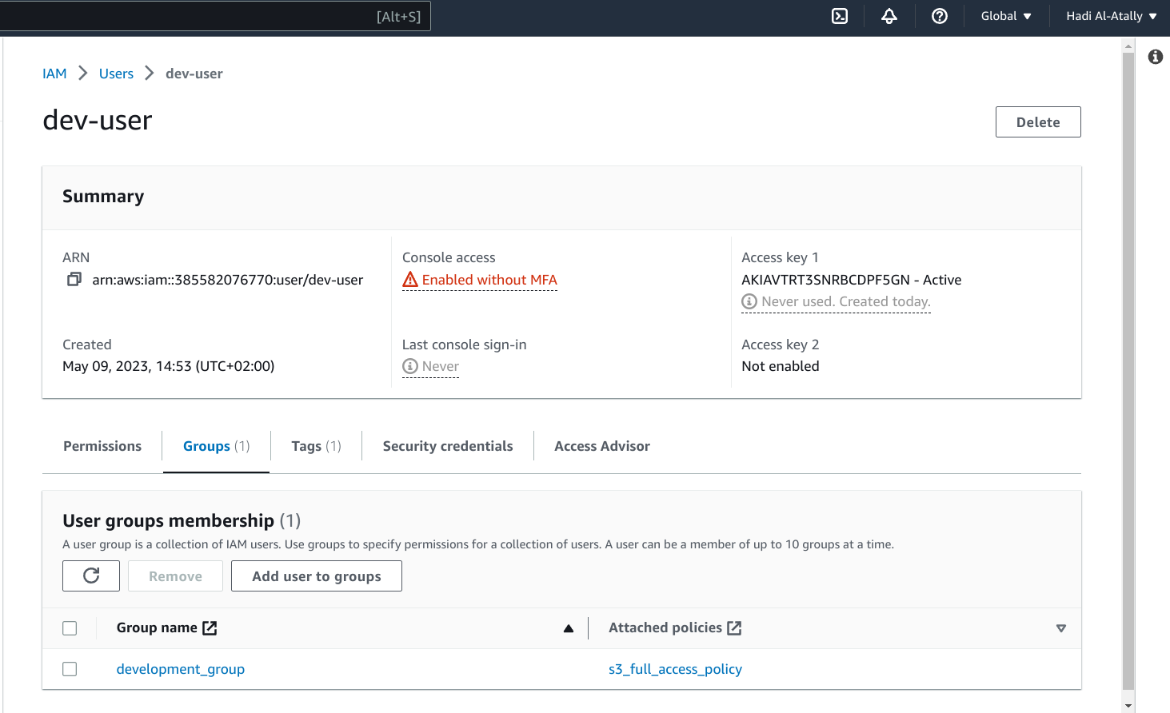

  - Also access cli using dev-user and try to get all users and groups using it

